**ORDERS SALES REPORT**

**1. Introduction** 

This report analyses order data to gain valuable insights into customer behaviour, sales trends, and overall business performance. Analysing order data allows us to identify areas for improvement, optimize marketing strategies, and make data-driven decisions to increase sales and customer satisfaction.

**2. Methodology**

* **Data Sources:**
  + The data for this analysis was obtained from orders sales database].
* **Data Cleaning and Preprocessing:**
  + Any inconsistencies or missing values in the data were identified and addressed through [describe cleaning methods, e.g., data imputation, outlier removal].
* **Analytical Techniques:**
  + This analysis utilized [mention techniques, e.g., descriptive statistics, time series analysis] to reveal trends and patterns within the order data.

**3. Requirement Analysis**

This section will vary depending on your specific goals. Here's an example:

* To understand customer purchasing habits, we will analyse order data based on:
  + Customer demographics (age, location, etc.)
  + Product categories purchased
  + Order frequency and average order value (AOV)

**Key Metrics (KPIs):**

* Number of orders
* Total revenue
* Customer acquisition cost (CAC)
* Customer lifetime value (CLTV)

**4. Other Parameters (Project Specific)**

This section allows you to tailor the report to your project. For example, you might analyze:

* **Product popularity:** Identify best-selling products and categories to inform inventory management and marketing campaigns.
* **Promotional effectiveness:** Analysed the impact of discounts and promotions on order volume and revenue.
* **Shipping performance:** Assess order fulfilment times and identify areas for improvement.

Explain how these parameters influence the overall analysis of orders.

**5. All Visualizations**

Use clear and concise titles and labels for all charts and visualizations created in Power BI. Examples include:

* **Bar Chart:** Compare order volume across different product categories or customer segments.

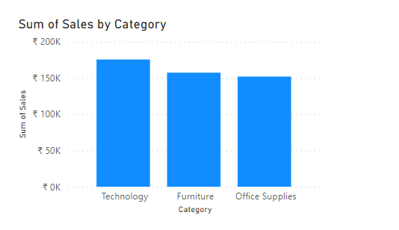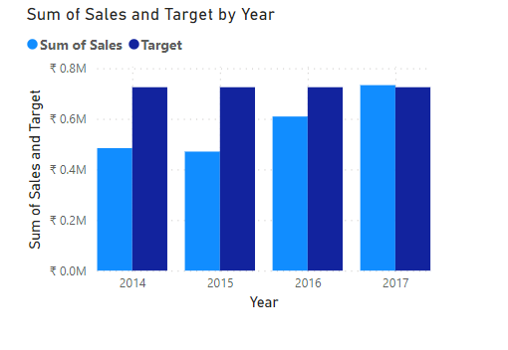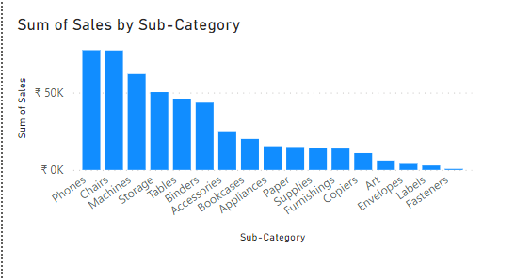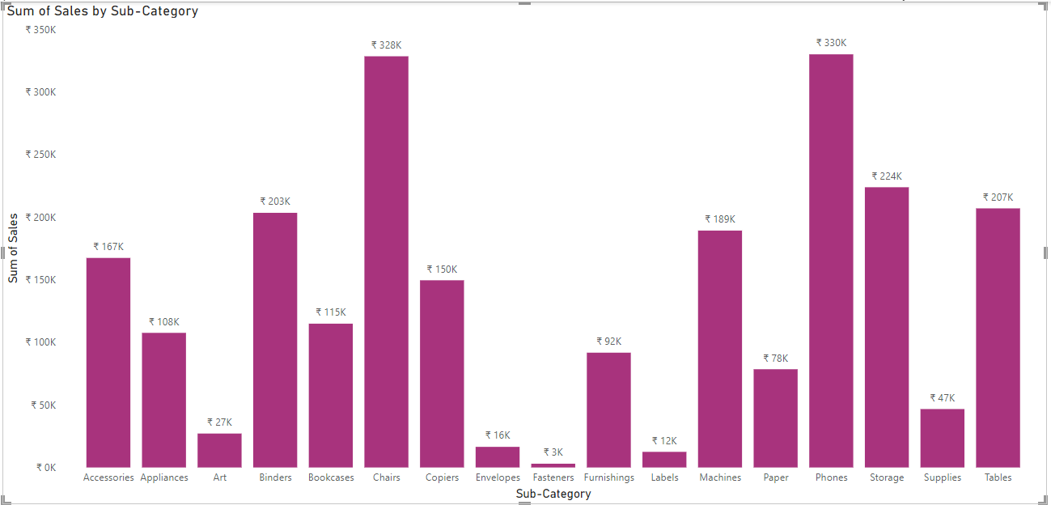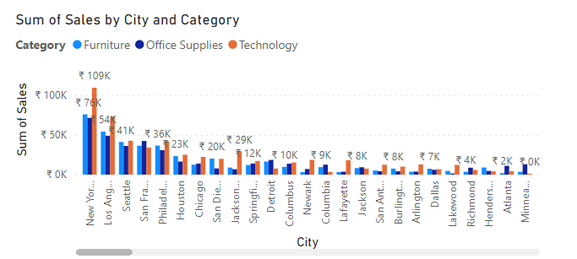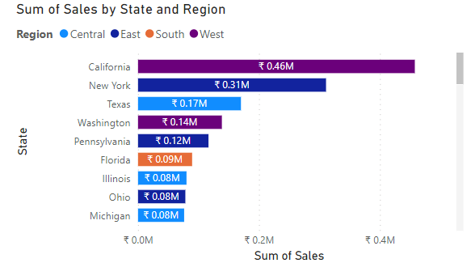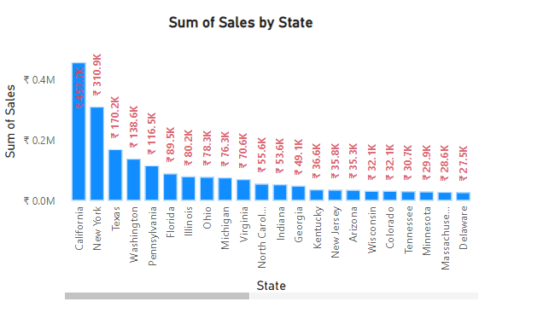

* **Line Chart:** Track trends in order volume and revenue over time.

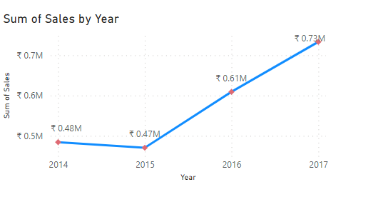

* **Pie Chart:** Show the distribution of orders by customer location or payment method.

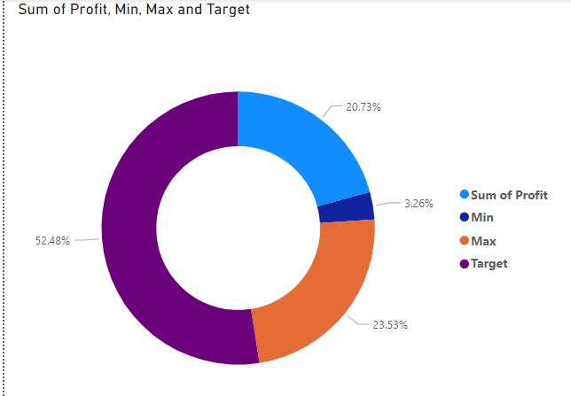

* **Scatter Plot:** Identify correlations between variables like order value and customer demographics.
* **Heatmap:** Visually represent complex data sets, such as order activity by day and time.

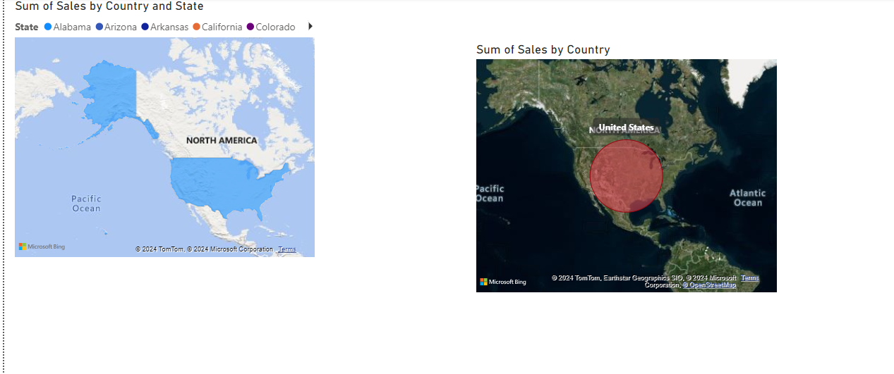

**6. Insights from the Charts and Dashboards**

Interpret your visualizations objectively. Here's an example:

* The bar chart reveals that [product category] is the most frequently ordered, suggesting a focus on promoting similar products.

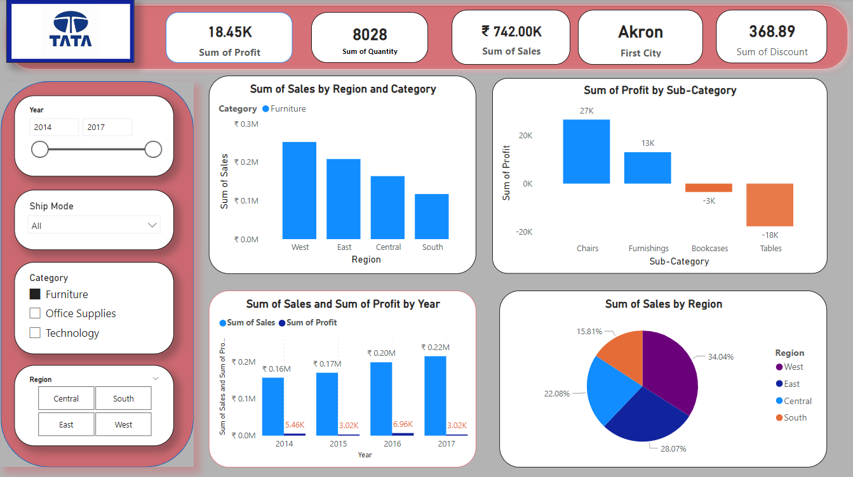

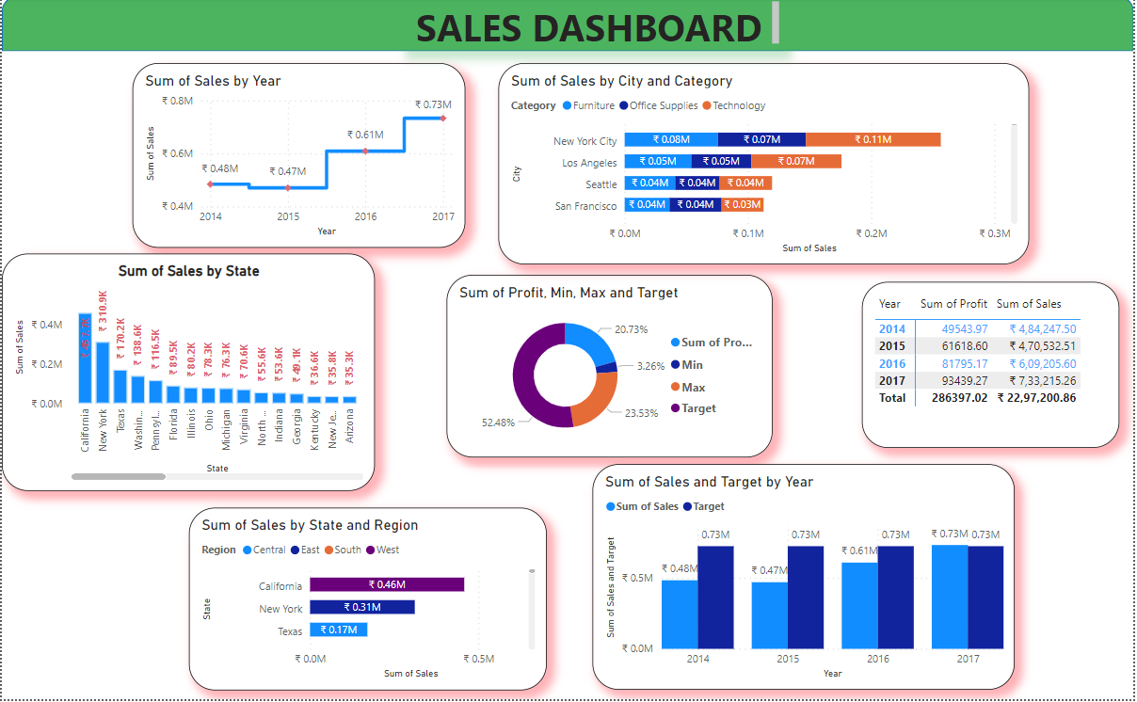

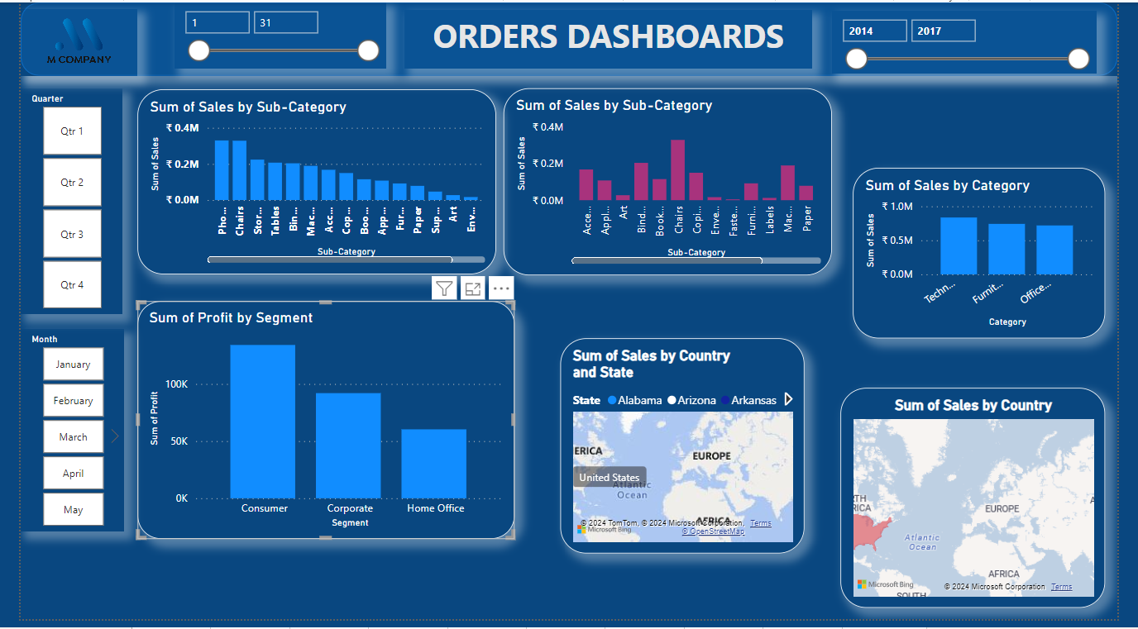

Identify:

* **Trends:** Are order volumes increasing or decreasing over time?
* **Patterns:** Are there any seasonal variations in order activity?
* **Anomalies:** Are there unexpected spikes or dips in order data that require further investigation?

**Actionable insights:** Based on your findings, recommend actions to improve business performance, such as:

* Targeting specific customer segments with personalized marketing campaigns.
* Optimizing product pricing and promotions.
* Streamlining the order fulfilment process.

**7. Conclusion**

Summarize the key findings and insights gleaned from the analysis. Based on your conclusions, provide recommendations for:

* **Decision-making:** How can these insights be used to make data-driven business decisions?
* **Further actions:** Are there any additional analyses required to gain deeper understanding?

Conclude by reiterating the value of ongoing order data analysis in driving business success.